MULTIPLE CHOICE 10 marks

- Which of the following is the best conductor of electricity at 25 °C?

  - H₂O(ℓ)
  - KCℓ(aq)
  - SiO₂(s)
  - NaCℓ(s)

- Which of the following best explains why diamond is a poor conductor of electricity?

  - It is a crystalline three dimensional lattice
  - It is made up of non-conducting carbon atoms
  - All of the valence electrons are involved in forming covalent bonds
  - It is a neutral substance since the number of electrons equals the number of protons

- Which of the following pairs of elements forms a compound be sharing electrons?

  - Sulfur and lead
  - Magnesium and oxygen
  - Nitrogen and bromine
  - Potassium and iodine

- What happens when solid calcium chloride dissolves in water?

  - Calcium chloride molecules are spread evenly throughout the water
  - Calcium atoms and chlorine atoms react with the water to form charged ions
  - Calcium ions and chloride ions separate from the fixed ionic lattice
  - Calcium atoms transfer electrons to chloride atoms to form Ca²⁺ and Cℓ⁻ ions.

- Which of the following best explains why graphite has a soft and slippery feel.

  - Graphite has delocalised electrons which act as charge carriers
  - There are weak dispersion forces between separate sheets of graphite
  - Each carbon atom in graphite is only bonded to three other atoms
  - There are strong covalent bonds joining each of the carbon atoms

- Element X has the electron configuration of 2,4 and element Y has the electron configuration 2,8,7. Which of the following best describes the compound formed between these elements?

  - It is a covalent molecular substance with the formula XY₄.
  - It is a covalent network substance with the formula XY₂
  - It is an ionic substance with the formula XY₄
  - It is an ionic substance with the formula XY₂

- Which of the following chemical species have a different electron configuration to the others?

  - K⁺
  - S²⁻
  - Aℓ³⁺
  - Ca²⁺

- The types of chemical reactions in hydrocarbons is determined by the nature of bonding within the molecules. When reactions with halogens (e.g. Br₂), hydrocarbons can either do addition or substitution reactions. Which option in the table below correctly classifies the type of reaction carried out by alkanes, alkenes and benzene?

 | Alkanes | Alkenes | Benzene
(a) | Substitution | Addition | Addition
(b) | Addition | Substitution | Substitution
(c) | Substitution | Addition | Substitution
(d) | Addition | Substitution | Addition

- What is the name of the substance produced when pent-1-ene reacts with Br₂?

  - 1-bromopentane
  - 2-bromopentane
  - 1,2-dibromopentane
  - 2,3-dibromopentane

- Which one of the following substances contains a different number of carbon atoms from all of the others?

  - 3-methylpentane
  - ethylbutane
  - hex-2-ene
  - methylbenzene

SHORT ANSWER 45 marks
- (6 marks)

- Write the formulas of the following compounds: (3 marks)
Answer | Marks
- BaCO₃ | 1 mark
- (NH₄)₂S | 1 mark
- CH₃COOH | 1 mark
Total marks: | 3 marks

- Write the names of the following compounds: (3 marks)
Answer | Marks
- Copper(II) oxide (must include oxidation state) | 1 mark
- Dinitrogen tetroxide | 1 mark
- Potassium cyanide | 1 mark
Total marks: | 3 marks

- (4 marks)

For each of the species listed below, draw the structural formula, representing all valence shell electron pairs either as : or as –. Water has been given as an example.
Species | Structure (showing all valence shell electrons)
Water  (H₂O) | ··  H — O — H  ··
Magnesium bromide  (MgBr₂) | ..  [ Mg ] ²⁺ + 2 [ : Br : ]⁻  ..
Carbon dioxide  (CO₂) | 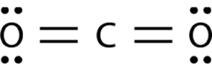

Answer | Marks
MgBr₂:  - Mg shown with no valence electrons. Br shown with 8 valence electrons  - MgBr₂ diagram includes square brackets, charges and coefficient | 1 mark  1 mark
CO₂:  - Correct number of covalent bonds joining each atom  - Correct number of valence electrons on each atom  (allow follow through if incorrect number of covalent bonds.) | 1 mark  1 mark
Total marks: | 4 marks

- (4 marks)

There are three types of strong bonding: metallic bonds, ionic bonds and covalent bonds. All of these bonds are based on electrostatic attraction between shared particles.

Complete the following table by listing the type of bond that occurs in each substance and stating

Compound | Silver | Diamond | Zinc oxide
Type of bonding | Metallic | Covalent | Ionic
Nature of attraction between particles | Electrostatic attraction occurs between  Ag⁺ ions  (OR Positive metal ions)  and  delocalised electrons | Electrostatic attraction occurs between  Positive nuclei  and  Shared electrons | Electrostatic attraction occurs between  Zn²⁺ ions  (OR Positive ions)  and  O²⁻ ions  (OR Negative ions)

Answer | Marks
Types of bonding match table above (all must be correct) | 1 mark
Attraction between particles matches table above | 6 x 0.5 marks
Total marks: | 4 marks

- (4 marks)

Silicon dioxide (SiO₂) and sulfur dioxide (SO₂) are both compounds that have covalent bonding. Despite this, SiO₂ melts at 1,600 °C whereas SO₂ melts at −72 °C. Explain in terms of structure and bonding why these substances have such different melting points.

The reason for this difference in melting points is due to the difference in structure and bonding in each material. Silicon dioxide is a covalent network substance and there are strong covalent bonds joining all atoms together. Sulfur dioxide is a covalent molecular substance and there are only weak intermolecular forces holding the individual molecules together. SO₂ has a much lower melting point because the intermolecular forces are much weaker than covalent bonds and need less energy to break.

Answer | Marks
Recognises that SiO₂ is covalent network but SO₂ is covalent molecular | 1 mark
States that there are strong covalent bonds joining all atoms in SIO₂ | 1 mark
States that there are weak intermolecular forces attracting molecules in SO₂ | 1 mark
Uses a comparison of the strength of covalent bonds vs intermolecular forces to explain the difference in melting points | 1 mark
Total marks: | 4 marks

- (5 marks)

Pure sodium metal reacts violently with fluorine gas (F₂) to form the ionic compound sodium fluoride.

- Write a balanced chemical equation for this reaction. (1 mark)

Answer | Marks
2 Na + F₂ 2 NaF | 1 mark
Total marks: | 1 mark

- In terms of electron transfer, describe what happens when an atom of sodium reacts with an atom of fluorine. (2 marks)

Answer | Marks
Sodium atom transfers an electron to a fluorine atom | 1 mark
…creating a positive sodium ion/Na⁺ ion and a negative fluoride ion/F⁻ ion | 1 mark
Total marks: | 2 marks

- Explain why sodium fluoride does not conduct electricity in the solid state but does conduct electricity when dissolved in water. (2 marks)

Answer | Marks
Doesn’t conduct electricity in the solid state because all ions part of a fixed lattice / are unable to move | 1 mark
Conducts when dissolved because ions are now free to move / are mobile charge carriers | 1 mark
Total marks: | 2 marks

- (6 marks)

Power lines in Australia were historically made of copper, but are now commonly made of aluminium. Aluminium is less dense than copper, which makes it lighter and easier to suspend between power poles.

- Draw a labelled diagram showing the structure and bonding within aluminium metal. (2 marks)

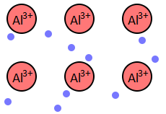
Delocalised electrons

Answer | Marks
Diagram has delocalised electrons / sea of delocalised electrons | 1 mark
Diagram has Al³⁺ ions in an orderly arrangement  (award only 0.5/1 if diagram says “positive ions” or “+” instead of “Al³⁺”) | 1 mark
Total marks: | 2 marks

- Other than lightness, list two properties of aluminium that make it suitable for using in electrical power cables. Explain in terms of structure and bonding why aluminium has each of these properties. (4 marks)

Answer | Marks
Conducts electricity (as a solid):  - Names property  - Explains reason (delocalised electrons act as mobile charge carriers) | 1 mark  1 mark
Ductility  - Names property  - Explains reason (atoms can move into new positions without break metallic bonds) | 1 mark  1 mark
Total marks: | 4 marks
Other properties may be possible but must be able to be linked to use in power cables to receive marks. Students could potentially list and explain high melting point. Award 1.5/2 if student refers to malleability instead of ductility. Do not accept malleability and ductility as separate properties.

- (8 marks)

Draw structures and give the names of organic molecules which fit the descriptions given in the table below.
Answer | Marks
1 mark per structural formula which is consistent with the given information. Different options will be possible. Examples given below. | 4 x 1 mark
1 mark per name which matches the given structural formula. Allow follow-through marks if the structure was attempt but was incorrect.  Do not award marks if a number is missing or is incorrect (e.g. “methylpentane” or “4-methylpentane” instead of “2-methylpentane”)  Award half a mark if an number was given but was not needed (e.g. “2-methylpropane” instead of “methylpropane”, or “1-chlorobenzene” instead of “chlorobenzene”) | 4 x 1 mark
Total marks: | 8 marks

A branched-chain alkane containing six carbon atoms | Structural formula:  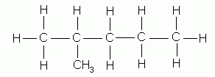 or 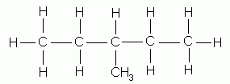  2-methylpentane 3-methylpentane  Also possible: 2,2-dimethylbutane, 2,3-dimethylbutane
An aromatic hydrocarbon that contains a halogen atom | Structural formula:  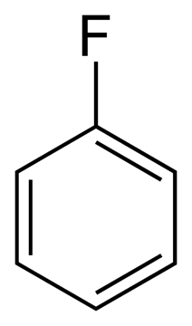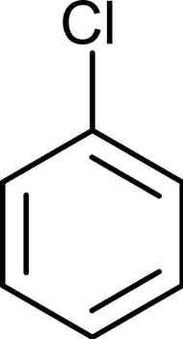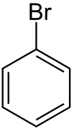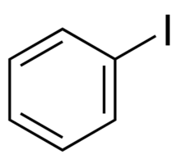  fluorobenzene chlorobenzene bromobenzene iodobenzene  More complicated variations are possible, but must contain a benzene ring and one of fluorine, chlorine, bromine or iodine.
Two different isomers which both have a molecular formula of C₄H₈. | 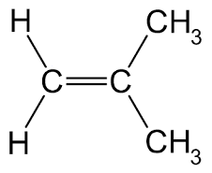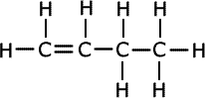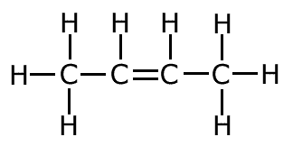  but-1-ene but-2-ene methylpropene  or 1-butene or 2-butene  Also possible: cyclobutane, methylcyclopropane
- (1 mark)
Write a balanced equation showing the combustion of propane (C₃H₈) in an excess of oxygen gas.
Answer | Marks
C₃H₈ + 5 O₂ 3 CO₂ + 4 H₂O | 1 mark
Total marks: | 1 mark

- (7 marks)
- Water is added to pent-1-ene in the presence of a sulfuric acid catalyst. (2 marks)

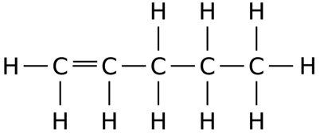
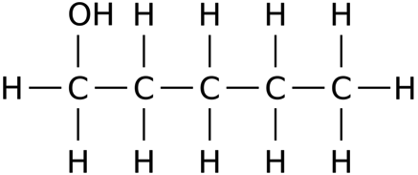
+ H₂O

Answer | Marks
Reactants are correct  - Correct structure of pent-1-ene | 1 mark
Products are correct  - Correct structure of pentan-1-ol OR pentan-2-ol | 1 mark
Total marks: | 2 marks

- A small amount of chlorine gas is bubbled through methylbenzene: (2 marks)
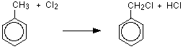

Answer | Marks
Reactants are correct  - Correct structure of methylbenzene | 1 mark
Products are correct  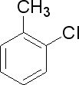  - Substitution has replaced a hydrogen atom with a chlorine atom  - HCl is a by-product  - Note: Also accept substitution on the benzene ring. Example: | 1 mark
Total marks: | 2 marks

- A small amount of methylpropane is added to an excess of bromine in the presence of UV light.
(3 marks)
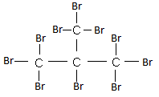
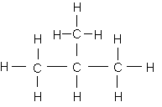
+ 10 Br₂ + 10 HBr

Answer | Marks
Correct structure for methylpropane | 1 mark
Shows a fully substituted product | 1 mark
Includes HBr as a byproduct and balances equation | 1 mark
Total marks: | 3 marks
Note: If student writes a correctly balanced equation for single substitution award 2/3 marks

